Use this guide to remove a student from a course section waitlist.
Before taking these steps, make sure you have the student’s name and course section information available.

INSTRUCTIONS

- Locate the search bar at the top of the page.

- Type “Remove Student from Waitlist”

- A pop-up window will appear with three fields – Student, Academic Period, and Course. Use the following table to complete the fields.

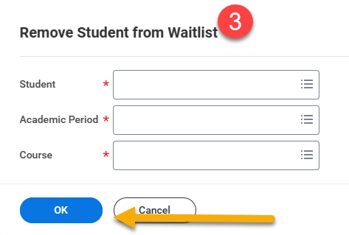
Field | Instructions
Student | Type the student name or the student ID and press “Enter”. If a drop-down menu populates with options, click the correct student. (You may only select one)
Academic Period | Click the “Academic Period” field and select the period associated with the course section in which the student is waitlisted. If no period is available, see the Troubleshoot section below.
Course | Click the “Course” field. Waitlisted courses associated with the student and period will auto-populate. Select the course from which you wish to remove the student. If no period is available, see the Troubleshooting section below.

- When finished, click “OK”


- Click “Done”


TROUBLESHOOT
The steps above will allow you to remove a student from a course section waitlist. If the steps do not work, it may be because the student is not on the waitlist. To confirm the student’s waitlist status, follow these steps.
- Open the student’s record by typing “Student: [First and Last Name]” in the search bar and select the student’s record.

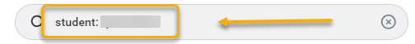
- In the student’s record, click “Academics” from the left-side menu and click the “Current Classes” tab.

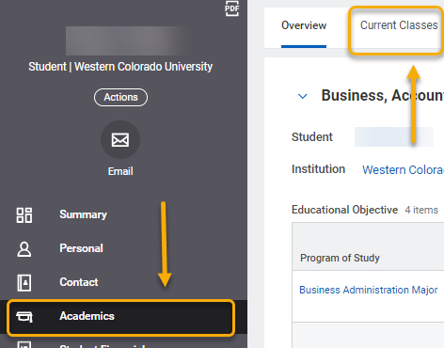
- Scroll down. If the student is on a waitlist, you will see the My Waitlisted Courses table with a list of the waitlisted courses underneath the My Enrolled Courses table. If there is no My Waitlisted Courses table, then the student is not on a waitlist.
